

Fundamentals of Programming

**Lab Manual # 8:**

**Submitted by:**

Muhammad Yahya Chand

**Roll no: 456727**

**Section: ME-15B**

**Submitted to:** Sir. Muhammad Affan

Date:6-12-2023

TASK # 1:

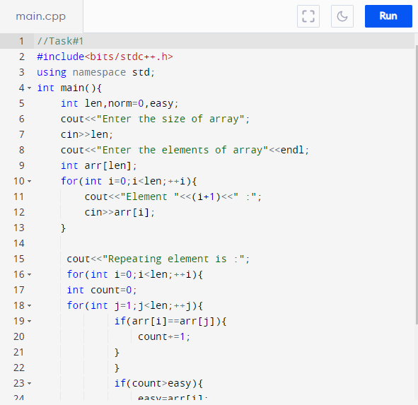

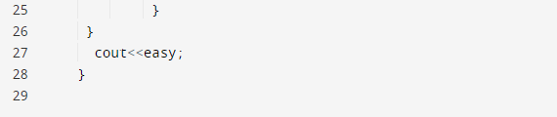

**Output:**

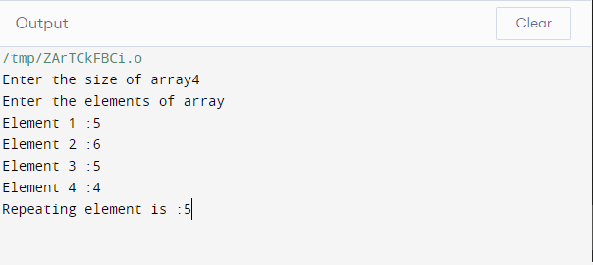

TASK# 2:

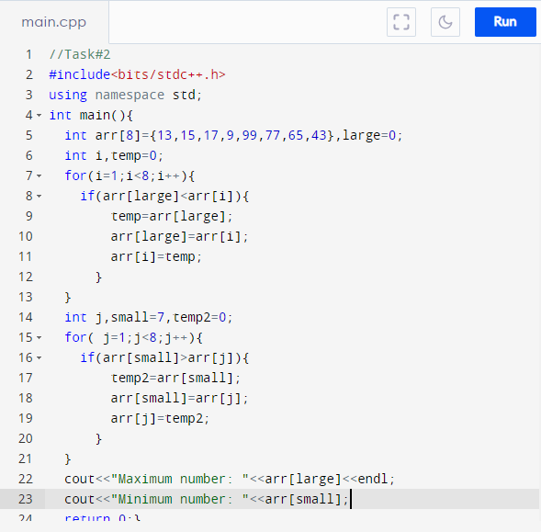

**Output:**

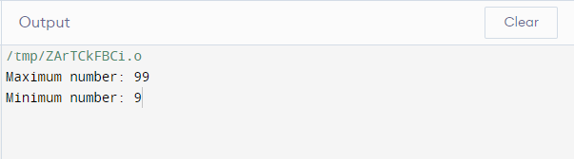

TASK #3:

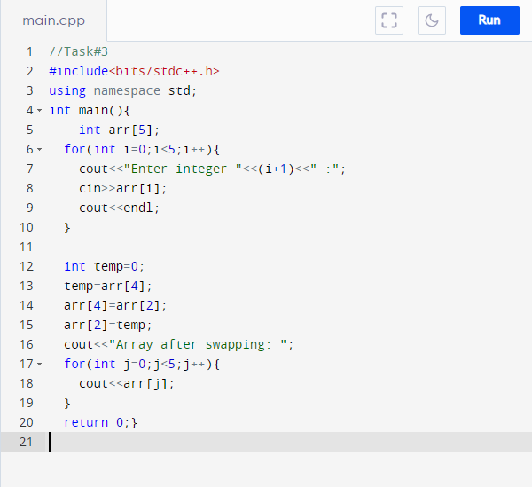

**Output:**

